Adaptive Image Enhancement for Robust Road Surface Crack Detection under Challenging Illumination Conditions

ARCHITECTURE DIAGRAM

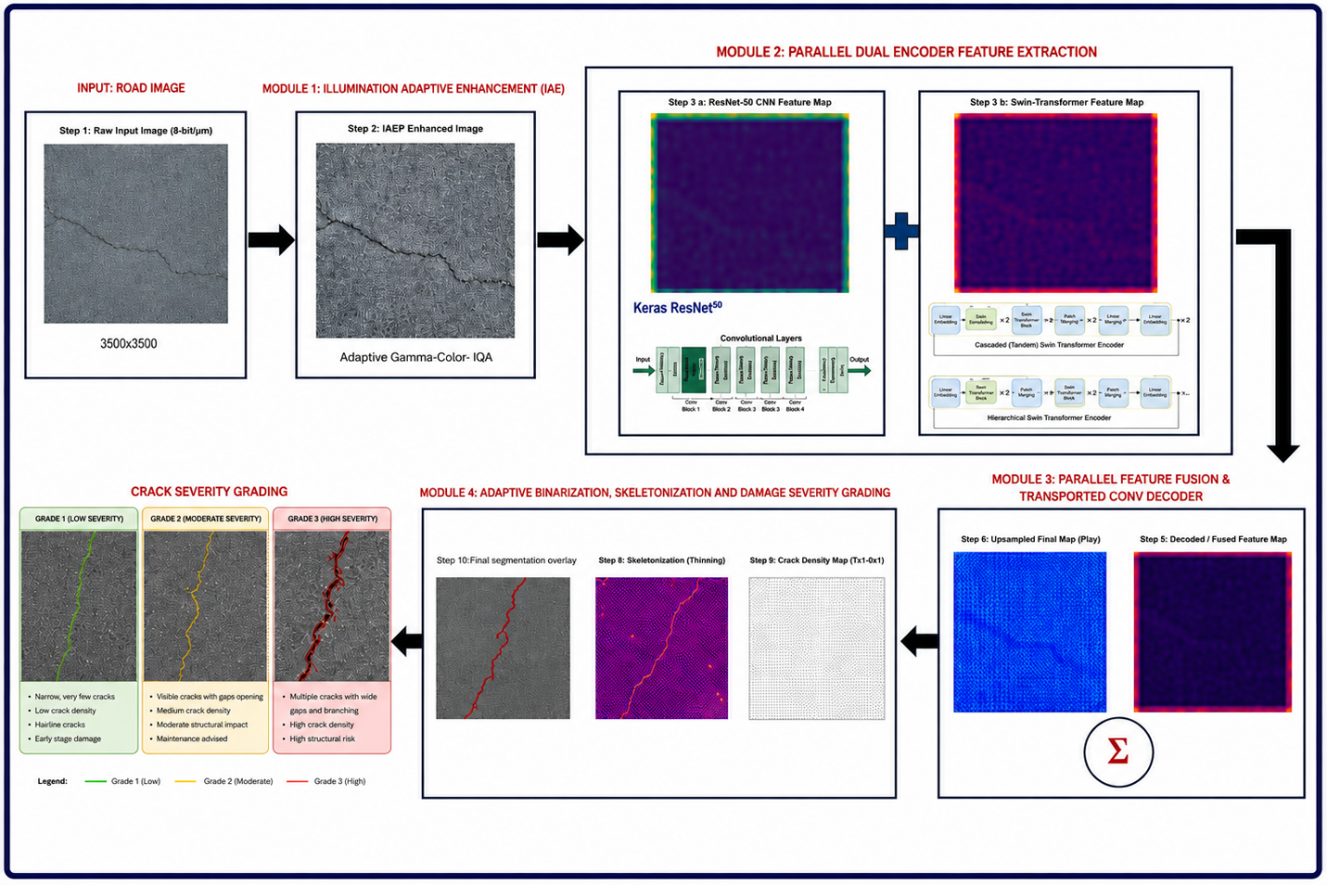

LIST OF MODULES
- Module 1- Illumination-Adaptive Enhancement Protocol (IAEP)
- Module 2 – Parallel Dual-Encoder Feature Extraction
- Module 3 – Parallel Feature Fusion & Transposed Convolutional Decoding
- Module 4 – Crack Refinement and Damage Assessment

ALGORITHM WITH SYMBOLS & NOTATIONS

Symbol | Mathematical Domain | Description / Definition
X | R^(B × 3 × 256 × 256) | Input batched RGB road surface image tensor from CrackForest Dataset (CFD)
X_gray | R^(B × 1 × 256 × 256) | Grayscale luminance intensity map converted from RGB tensor X
μ_I | R | Global mean luminance value across image pixels (0 ≤ μ_I ≤ 255)
σ_I² | R | Global luminance variance evaluating non-uniform shadow distribution
σ_n² | R | Estimated Gaussian sensor noise variance derived via Laplacian kernel
C_local | R | Root Mean Square (RMS) local contrast evaluation score
Q | R^(B × 4) | Diagnostic Image Quality Assessment (IQA) vector [μ_I, σ_I², σ_n², C_local]
γ_adapt | R⁺ | Dynamically computed non-linear exponent for adaptive gamma transformation
I_gamma | R^(B × 3 × 256 × 256) | Gamma-corrected image representation optimized for low-light/glare
I_retinex | R^(B × 3 × 256 × 256) | Multi-Scale Retinex with Color Restoration (MSRCR) image representation
I_clahe | R^(B × 3 × 256 × 256) | Contrast Limited Adaptive Histogram Equalization image representation
w₁, w₂, w₃ | R ∈ [0, 1] | Softmax adaptive gating weights for branch fusion (Σᵢ₌₁³ wᵢ = 1.0)
I_enh | R^(B × 3 × 256 × 256) | Fused adaptive enhanced image tensor supplied to neural backbones
F_cnn | R^(B × 512 × 32 × 32) | Local high-resolution spatial feature map extracted from ResNet-50 Stage 3
F_trans | R^(B × 2048 × 8 × 8) | Global contextual feature embedding extracted from Swin Transformer Stage 4
S_map, C_map | R^(B × 1 × 64 × 64), R^(B × 1024 × 1 × 1) | Spatial Attention Map and Channel Attention Map matrices
F_fused | R^(B × 512 × 64 × 64) | Edge-aware recalibrated fused feature map output from MSFF module
M̂ | {0,1}^(B × 1 × 256 × 256) | Predicted binary pixel-level crack segmentation mask
S | {0,1}^(256 × 256) | Morphological 1-pixel thin skeleton matrix of detected crack network
D_euclid | R^(256 × 256) | Euclidean distance map measuring distance from crack pixel to non-crack border
s | R⁺ | Physical spatial calibration ratio (mm / pixel)
L_mm, W_max | R⁺ | Quantified crack length (mm) and maximum crack width (mm)
D_% | R ∈ [0, 100%] | Ratio of crack surface pixels to total road inspection region
G | Categorical | Damage severity classification grade (Grade 1: Minor, Grade 2: Moderate, Grade 3: Severe)

PROPOSED METHODOLOGY (Overview of the Proposed Framework)
The projected approach includes an Illumination-Adaptive Enhancement and Parallel Dual-Encoder Network (IAEP-Net) to achieve accurate pavement crack detection and the severity of damage in difficult scenarios such as non-uniform illumination, shadows and low contrast road surfaces. It is a framework of four progressive modules which are operated in an end-to-end fashion.
First the input pavement image is enhanced by illumination through Image Quality Assessment (IQA), adaptive gamma correction, and even Contrast Limited Adaptive Histogram Equalization (CLAHE), which preserves structural information while improving the visibility of the image. The improved image is then entered into a parallel dual-encoder architecture that contains a ResNet-50 network to learn fine local features of cracks and a Swin Transformer network to learn long-range context.
The features extracted are combined, and then entered into a transposed convolution decoder to produce a crack probability map at the pixel level. Finally, adaptive thresholding, morphological processing, connected component analysis, skeletonization, and Euclidean Distance Transform (EDT) are applied to get a refined crack segmentation mask, estimate crack width and surface density, classify pavement as cracked or not, and assign a standard damage severity grade ranging from Grade 0 (Normal) to Grade (Severe). This integrated framework provides effective crack segmentation and accurate damage assessment for intelligent road inspection system applications.

ARCHITECTURE DIAGRAM

ALGORITHM
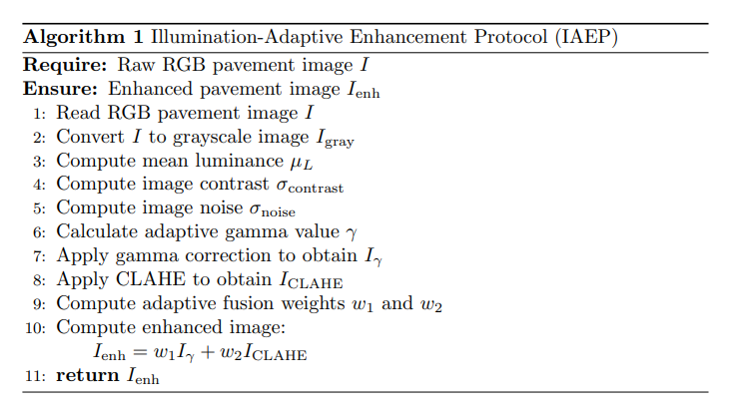
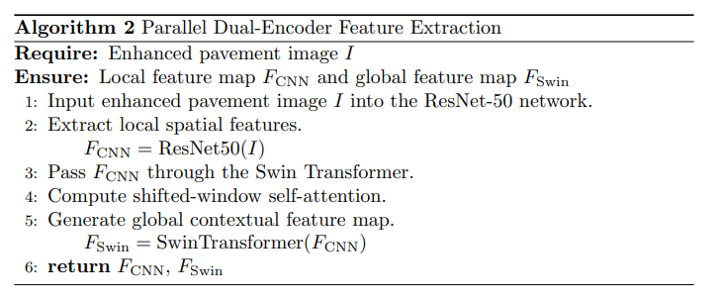
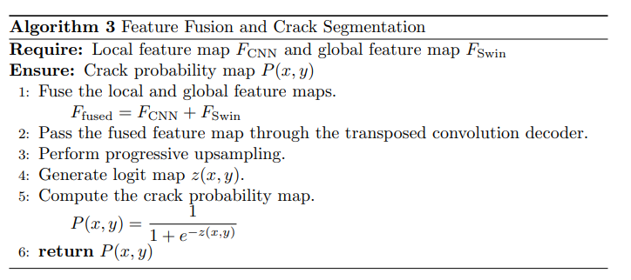
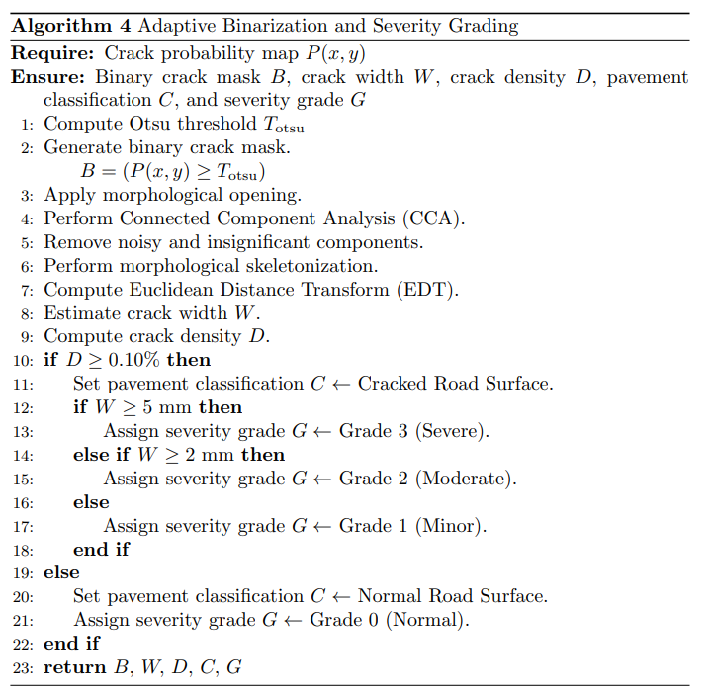

ALGORITHM(STEPS)
1.Obtain an RGB pavement image, I.
--------------- MODULE 1 ----------------
2. It performs Image Quality Assessment (IQA).
3. Calculates the brightness, contrast and noise of images.
4.Apply Adaptive Gamma Correction
5. Import the image using Import/Export Filter.
6. Use CLAHE to enhance local contrast.
7. Enhance images by fuse using adaptive weighted fuse.
8. Create improved Ienh of image.
--------------- MODULE 2 ----------------
9. Add 8 to ResNet-50.
10. Extract Local Crack Feature Map FCNN.
11. Obtain the features using the Swin Transformer.
12. Feed the FCNN into the Swin Transformer.
13. Load a contextual feature map for the globe: FSwin.
--------------- MODULE 3 ----------------
14. Create fusion of FCNN and FSwin.
15. Pass fused features to decoder.
Perform Transposed Convolution upsampling.
16. Create a probability map P of pixels.
--------------- MODULE 4 ----------------
17. Apply Otsu thresholding.
18. Generate binary crack mask B.Generate a binary crack mask B.
19. Perform morphological opening.
20. Use Connected Component Analysis.
21. Eliminate small noisy parts.
22. Perform Skeletonization.
23. Compute Euclidean Distance Transform:
- Estimate the width of a crack W.
- Calculate Crack density D.
24. Classify pavement condition:
- Assign a damage severity grade for G.
- Return B, W, D, C, G.

PROPOSED METHODOLOGY DESCRIPTION
1.Pattern Recognition and Analysis of the acquired images
1.1 Input Pavement Image Acquisition
The system starts by acquiring the RGB pavement images from the road inspection cameras. The images can be inconsistently lit, shadowed, have reflections and variations in crack pattern which can influence segmentation. The intended framework is used to process the captured images as well.
1.2 Illumination-Adaptive Image Enhancement
The framework first performs Image Quality Assessment (IQA) to study the brightness level , contrast, and noise level of the images to improve their quality of it. Based on these statistics, (adaptive gamma correction) is used to normalize the light, and CLAHE is used to increase the contrast in the local image without increasing the noise. To conclude, we have an illumination balanced image is derived by adaptive weighted fusion of both enhanced images for further processing it.
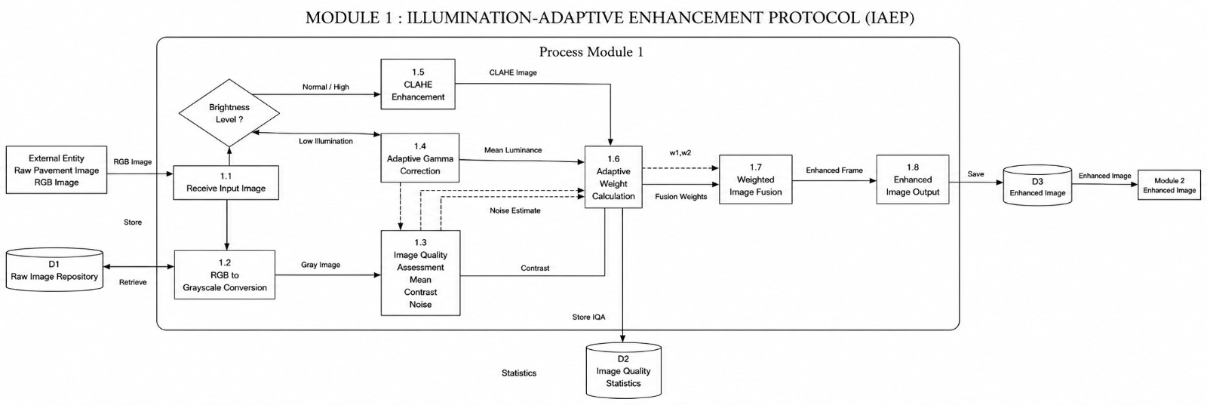

2. Parallel Dual-Encoder Feature Extraction
2.1 Local Feature Extraction using ResNet-50
Assembled by a ResNet-50 convolutional neural network, the enhanced pavement image is used to extract fine-grained spatial features including crack edges, textures and thin fracture patterns. The local features can contain detailed structural information needed to localize cracks accurately. Global Context Extraction based on Swin Transformer , Global Context Extraction with Swin Transformer.
At the same time, these CNN features are given as input into a Swin Transformer using shifted-window self-attention to learn long-range spatial relations between the pavement image. This will allow the framework to become aware of the continuity of cracks and larger patterns in the structure that can be more readily detected than just by convolution.
The third feature is Feature Fusion and Crack Segmentation .The third feature is Feature Fusion and Crack Segmentation.
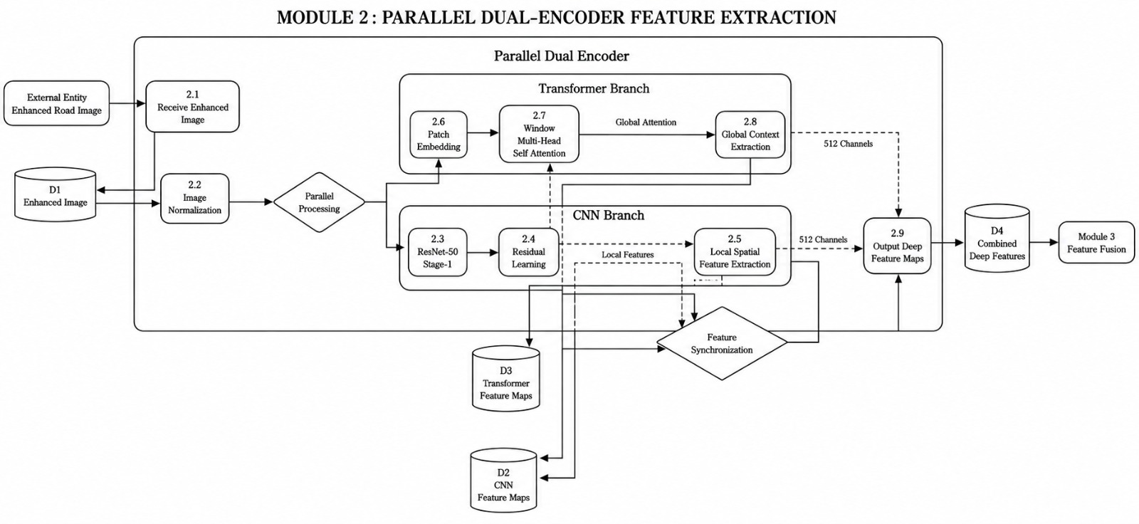
3.1 Parallel Feature Fusion
Element-wise residual addition is used to fuse the local features generated by ResNet-50, and the global contextual features extracted by the Swin Transformer. So, the local information on the edges is combined with the global context to have a global representation of features.
3.2 Transposed Convolution Decoder
The fused feature map is then provided into a multi-stage transposed convolution decoder that gradually up-samples the feature maps to the original image resolution. To create a probability map of each pixel representing the probability of the pixel being a pavement crack, a sigmoid activation function is applied.
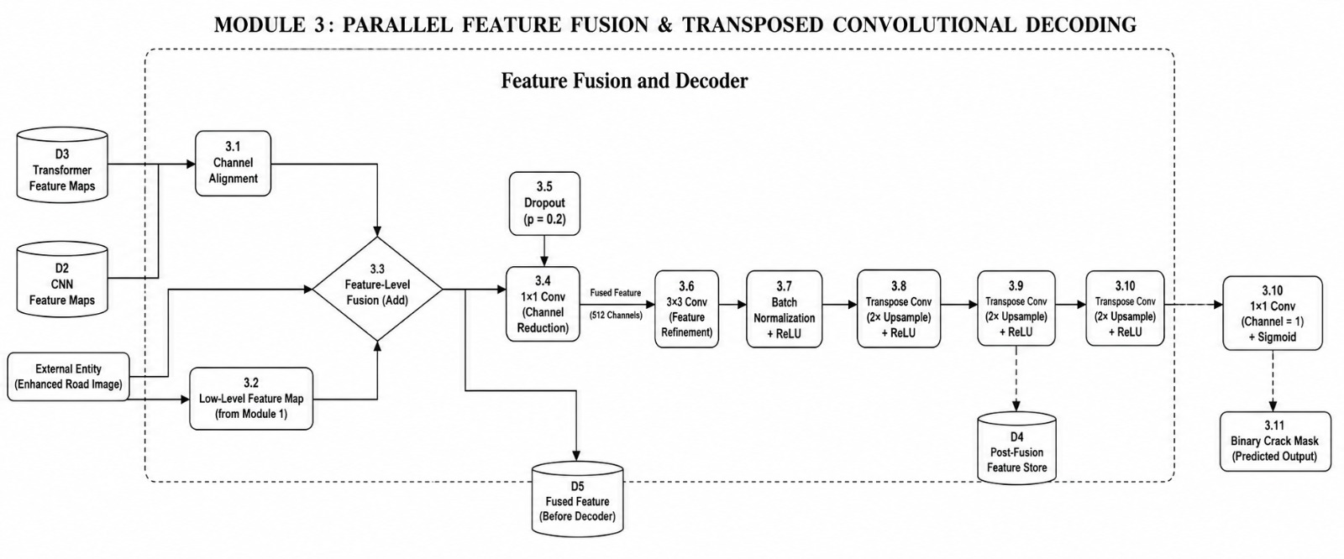

4. Crack Refinement and Damage Assessment
4.1 Adaptive Binarization
Otsu's adaptive thresholding method is used to turn the probability map into a binary crack mask. The morphological opening operation is then applied to eliminate isolated noise pixels and leave only significant and important crack areas.
4.2 Connected Component Analysis
The Connected Component Analysis (CCA) method is performed to create distinct regions of cracks, and small components as well as aspect ratio out of range are eliminated to remove false detections and keep only structural cracks.
4.3 Skeletonization and Crack Width Estimation
The binary crack image is skeletonized to get a 1-pixel wide centerline of the crack. The Euclidean Distance Transform (EDT) is then used to measure the distance between the skeleton and the crack boundaries to estimate the maximum crack width, from which a physical width can be estimated after calibration.

4.4 Crack Density Measurement
The number of surface cracks is determined by the percentage of the pavement area covered by detected cracks and the framework calculates crack surface density based on this value. This is a quantitative assessment of the overall condition of the pavement deterioration.
Pavement classification and severity grading:
Lastly, the measured crack width, crack density, and structural characteristics are analyzed using pre-defined decision rules to classify the pavement as Cracked Road Surface or Uncracked/Normal Road. The pavement condition is classified into four standardized severity grades: Normal (Grade 0), Minor (Grade 1), Moderate (Grade 2) and Severe (Grade 3) for effective maintenance planning and decision making based on the estimated crack width.
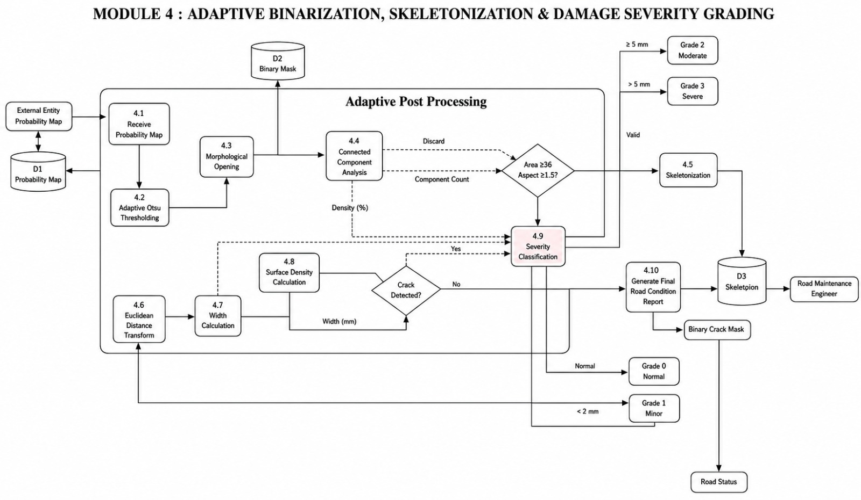

DATAFLOW DIAGRAM
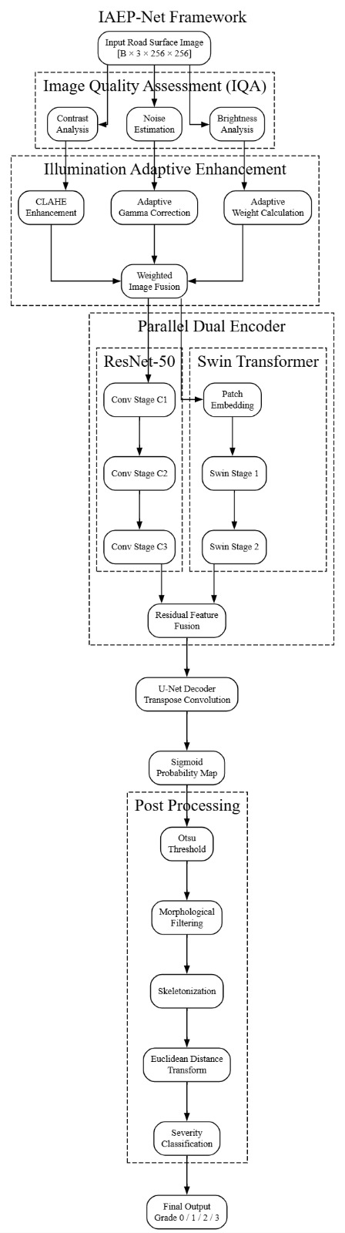

DATASET OVERVIEW

- The dataset contains ~2,000 cracked/uncracked asphalt images at 1440×1440 resolution, plus 8,000+ images at 360×360 and 3,000+ at 720×720.
- The sets with the lower resolution were produced by splitting the original 1440x1440 images and the generation of cracked&uncracked “sub” images.
- All images have the same scale because the image data was taken with a fixed camera height, working distance and field of view.
- The consistency of the scale makes it possible to compare the width and length of cracks directly between images.
- A vehicle-mounted camera in a custom plywood chamber (1440X1440 resolution, 30 fps) was used to gather data.
- The bottom of the chamber was covered by a Perspex screen, which was used to keep the camera safe and provided a clear view down the chamber.
- The chamber was fitted on an off-the-shelf bicycle carrier that mounted the camera to a car's tow bar, which allowed the filming to be done while the rider was on the road.
- The data set can be used to train deep learning models and to calculate pavement crack widths, additional details of which are contained in the linked Construction and Building Materials journal article.

